**Final Project**

Brandon Trinkle

Information Technology, Arizona State University

IFT 320: Managing The Cloud

Professor Rahul Kashyap

10/6/2024

ASU Inc., a leader in applied supercomputing, is at a crucial juncture as its physical infrastructure approaches the end of its operational life. Facing growing demands for capacity and flexibility, ASU Inc.’s Chief Technology Officer (CTO) has proposed a strategic shift to Amazon Web Services (AWS) as a replacement for its aging on-premises systems. This document serves as a justification for this transition, analyzing AWS’s suitability from both a cost and computing perspective. The analysis includes estimated one-year and three-year costs, cost minimization strategies, and an overview of the migration process, showcasing the financial and operational viability of AWS for ASU Inc.

**Cost Analysis: One-Year and Three-Year AWS Costs**

To address ASU Inc.’s requirements, we estimated costs for four key AWS resources: database servers, non-database servers, Amazon S3 storage, and Elastic Block Storage (EBS). The one-year and three-year costs are calculated for various configurations to provide a comparative view of financial commitments:

1. Database Servers: ASU Inc. requires 20 Microsoft SQL Windows servers, each with 64GB of RAM and 4 CPU cores. For consistent workloads, Reserved Instances (RIs) offer up to 75% savings over On-Demand Instances. Based on AWS’s pricing calculator, the one-year cost for these servers using RIs totals approximately $300,000, while a three-year commitment reduces costs significantly to around $650,000 due to AWS’s reserved pricing structure.
2. Non-Database Linux Servers: The current server farm, consisting of 200 Linux servers (8GB RAM and 2 CPU cores each), will be rehosted on AWS. RIs for these instances bring one-year costs to roughly $700,000 and three-year costs to about $1.4 million. With right-sizing options and auto-scaling, ASU Inc. can optimize these costs further.
3. S3 Storage: To support application storage, ASU Inc. will use 25 TB of Amazon S3 storage. S3 offers different pricing tiers based on storage class, access frequency, and lifecycle policies. Using S3 Standard and S3 Glacier for infrequent access, the estimated cost is $7,000 annually. This cost remains consistent across both one-year and three-year terms due to the pricing model.
4. EBS Storage: For OS storage, 10 TB of Elastic Block Storage (EBS) will be provisioned. Standard EBS costs approximately $1,200 per year, while using Cold HDD storage could cut costs by 50% for data that does not need frequent access.

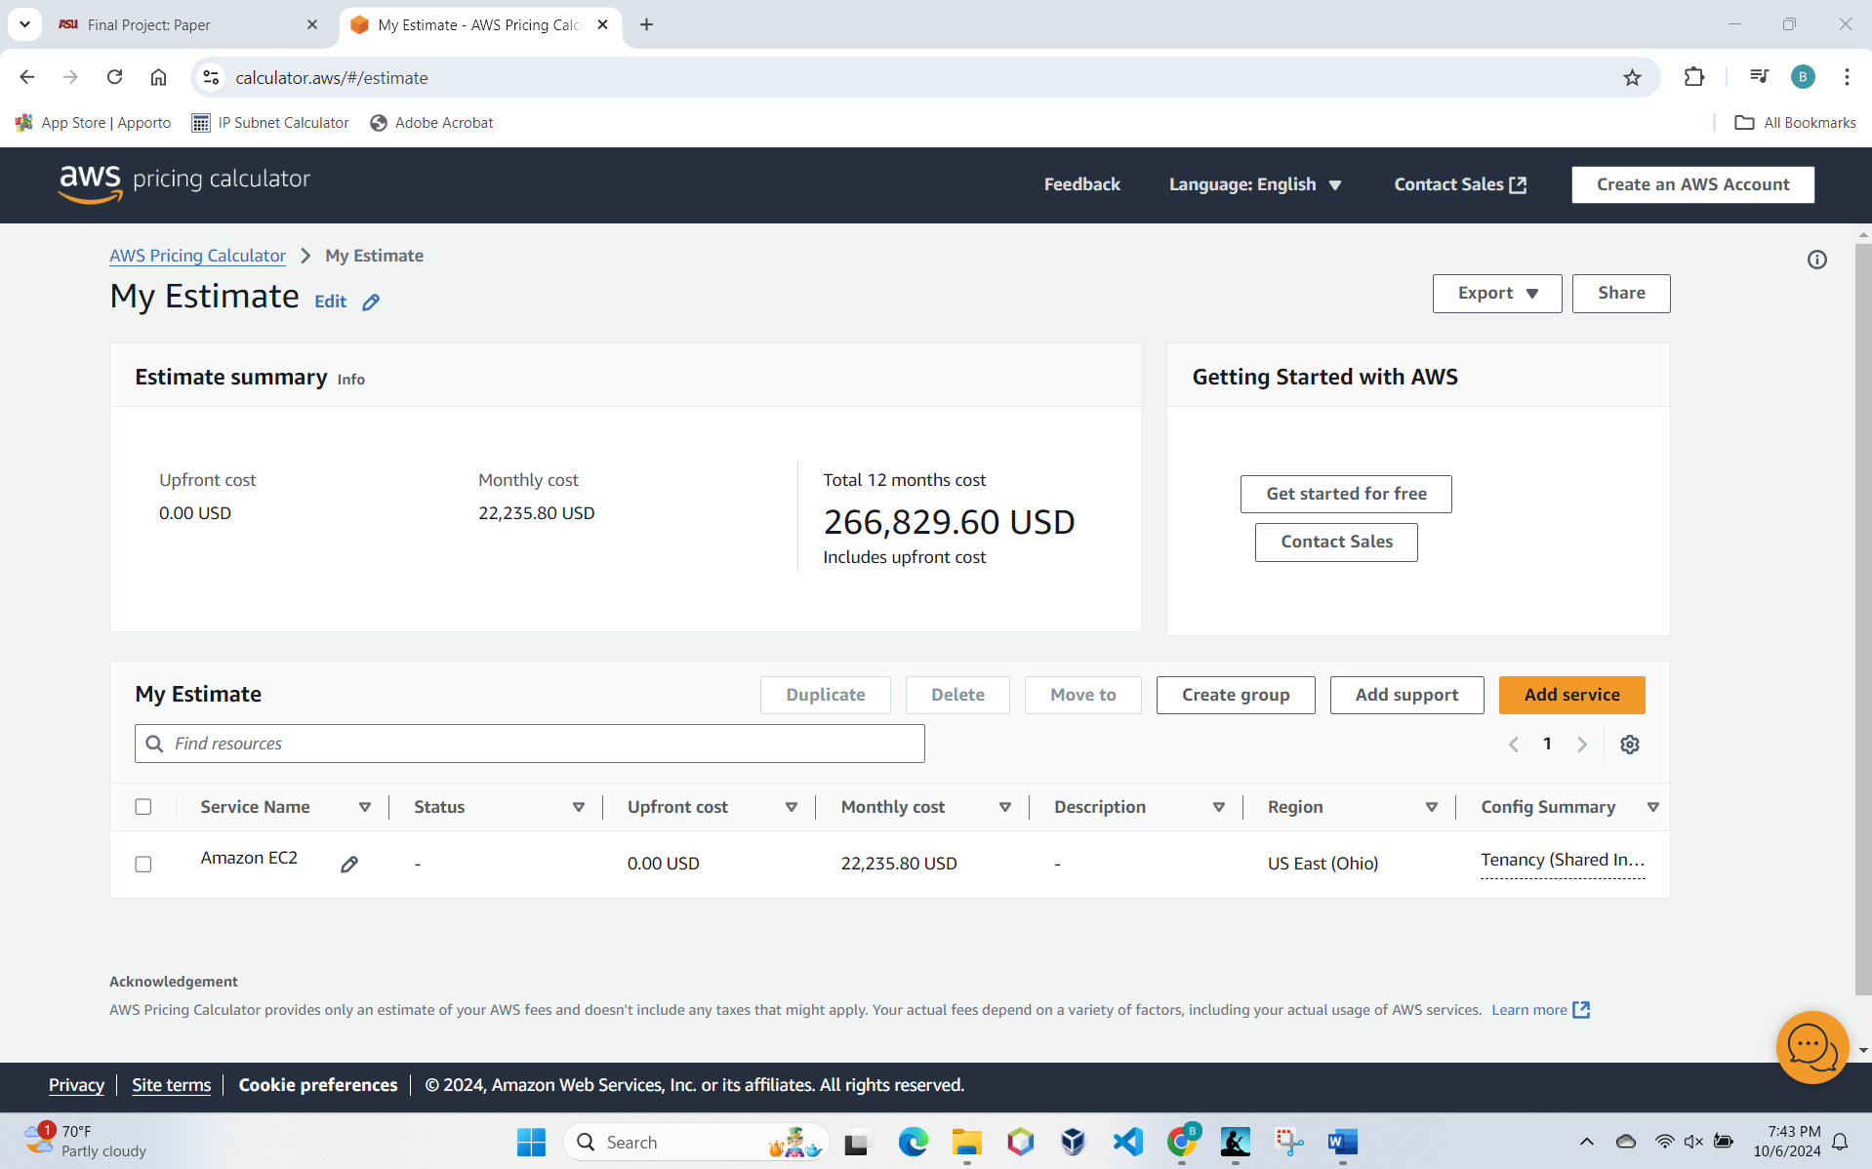

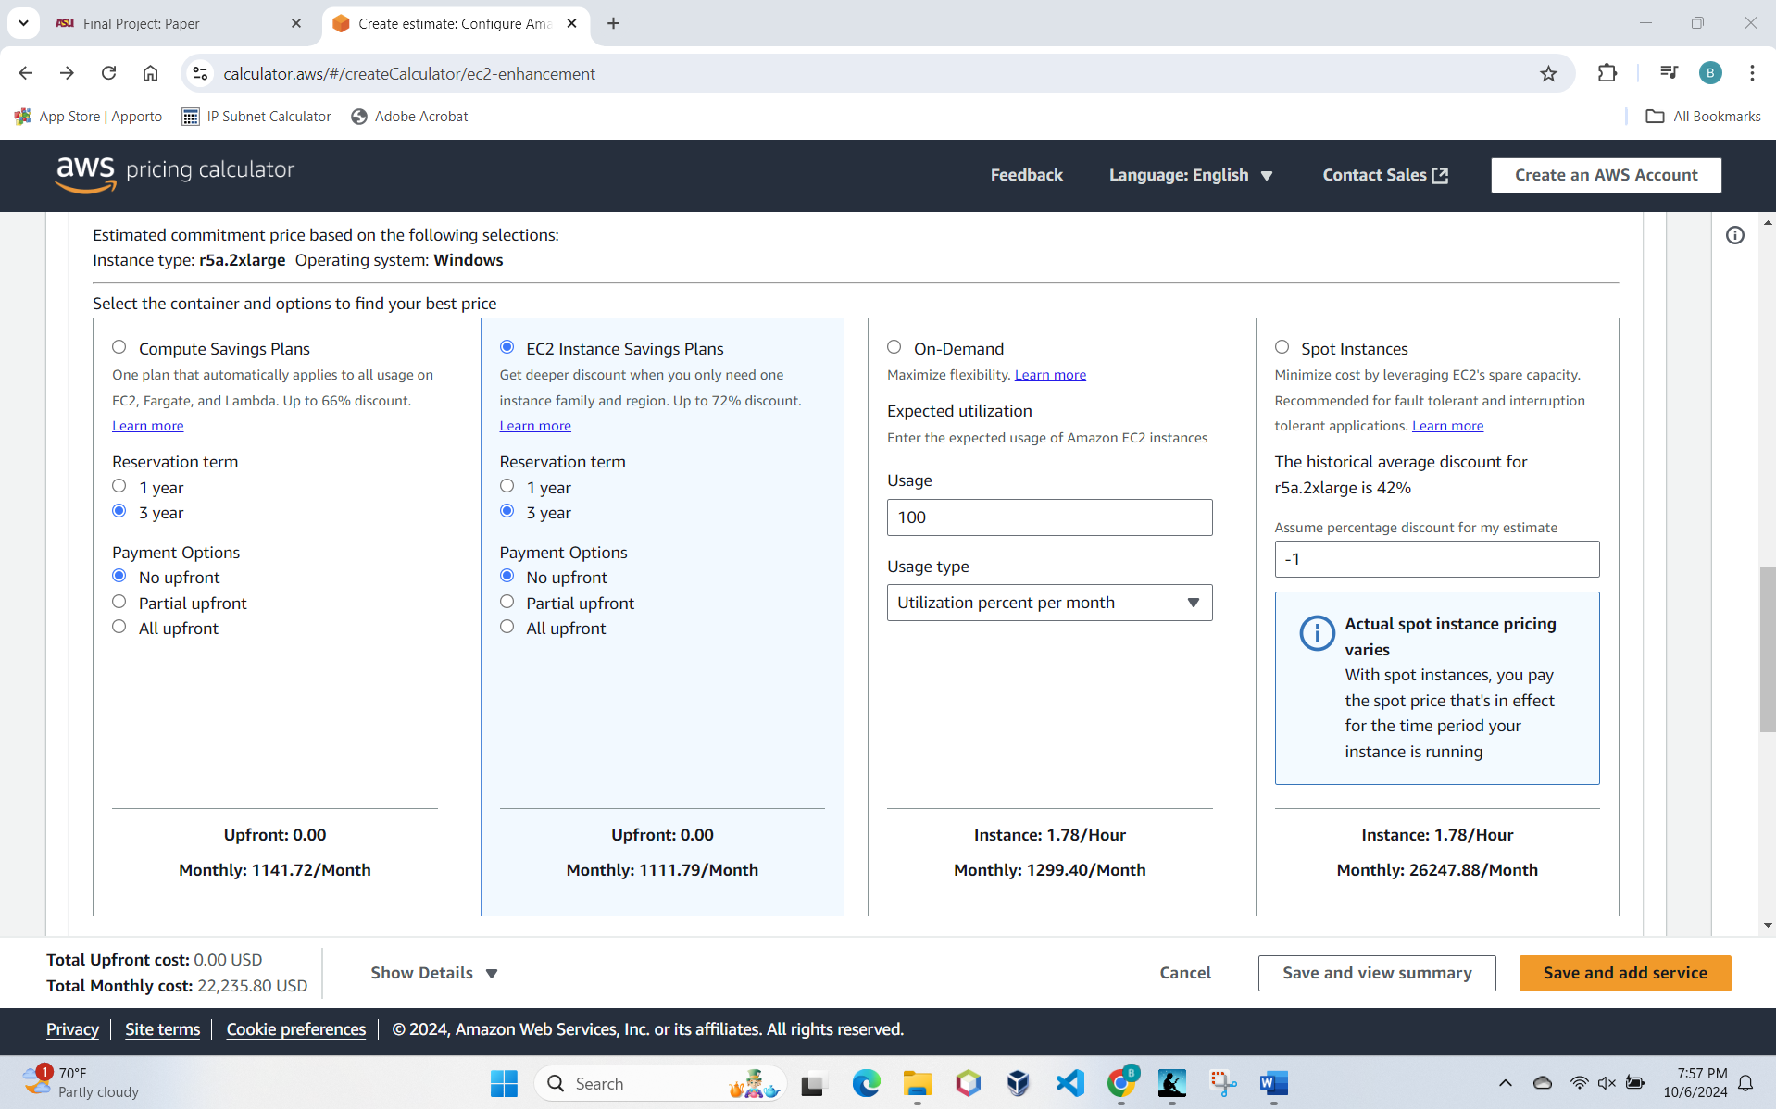

The AWS Pricing Calculator provides detailed cost breakdowns and a cost summary, supporting the conclusion that a three-year commitment with RIs provides a reliable cost structure that scales with ASU Inc.'s future growth needs.

**Cost Minimization Strategies for AWS**

To maximize cost efficiency, ASU Inc. can take advantage of several AWS options designed to reduce expenditures while retaining performance:

* Reserved Instances and Savings Plans: AWS’s Reserved Instances (RIs) and Savings Plans allow companies to commit to one- or three-year terms for predictable workloads, saving up to 75% over On-Demand pricing. This approach is particularly advantageous for ASU Inc.’s database servers and core applications, which have stable demand patterns.
* Spot Instances: For less critical, interruptible tasks, Spot Instances provide access to unused AWS capacity at a discount of up to 90%. Applications that can tolerate interruptions, such as batch processing and non-urgent analytics, are well-suited for Spot Instances.
* Auto Scaling and Right-Sizing: Auto Scaling automatically adjusts instance capacity based on demand, which prevents over-provisioning and underutilization. Right-sizing tools further optimize resources, ensuring that ASU Inc. only pays for the capacity it actively uses.
* S3 Storage Classes: Amazon S3 offers multiple storage classes based on data access frequency. S3 Standard-Infrequent Access and S3 Glacier are cost-effective for long-term data storage, providing ASU Inc. with low-cost options for archiving data and reducing costs on less frequently accessed files.

These cost-saving strategies ensure that ASU Inc. maximizes its cloud investment, balancing flexibility with long-term savings.

**AWS Migration Process Overview**

Transitioning ASU Inc.’s infrastructure to AWS involves several stages to ensure minimal disruption, compatibility, and scalability:

* Assessment: The initial step involves a comprehensive assessment of ASU Inc.’s existing infrastructure. AWS Migration Evaluator can generate detailed reports on current hardware costs and forecast AWS expenses. This phase helps identify application dependencies, workload requirements, and potential challenges.
* Planning: A structured migration plan is developed, outlining a sequence for moving each application. This includes defining stakeholder roles, timelines, and resource allocation. AWS Migration Hub assists with project management, centralizing migration tasks for efficiency.
* Pilot Migration: To reduce migration risks, ASU Inc. will conduct a pilot migration on a select group of applications, allowing IT teams to resolve issues before a full rollout. This approach ensures a stable environment and minimizes downtime for critical applications.
* Data Migration and Application Re-Hosting: Using AWS Database Migration Service (DMS) and AWS Server Migration Service (SMS), ASU Inc. can transfer SQL Server databases and Linux-based applications seamlessly. DMS supports both homogeneous and heterogeneous migrations, ensuring data integrity and continuous operation.
* Optimization and Monitoring: Post-migration, AWS tools like CloudWatch and Cost Explorer provide insights into resource utilization and expenditure, enabling ASU Inc. to fine-tune its cloud setup for optimal cost and performance.

**Conclusion**

The migration to AWS aligns with ASU Inc.’s long-term goals by offering a scalable, flexible, and financially viable infrastructure solution. The cost analysis shows that AWS’s three-year reserved pricing provides a sustainable approach, while strategies like Reserved Instances, Spot Instances, and right-sizing enhance cost-effectiveness. The migration process, supported by AWS’s advanced migration services, ensures that ASU Inc. can transition with minimal disruption. With AWS, ASU Inc. is well-positioned to meet its growing demands, gain operational agility, and reduce total cost of ownership.

# References

Amazon. (2024, October 6). *Amazon S3 Storage Classes*. Retrieved from aws.amazon.com: https://aws.amazon.com/s3/storage-classes/

Amazon. (2024, October 6). *How to Migrate*. Retrieved from aws.amazon.com: https://aws.amazon.com/migrate-modernize-build/cloud-migration/how-to-migrate/

Amazon. (2024, October 6). *Migrate and Modernize with AWS*. Retrieved from aws.amazon.com: https://aws.amazon.com/migrate-modernize-build/cloud-migration/

AWS. (2024, October 5). *Amazon EC2 Pricing*. Retrieved from Amazon.com: https://aws.amazon.com/ec2/pricing/

Guide to Cloud Computing for Business and Technology Managers. (2015). In V. Kale, *Guide to Cloud Computing for Business and Technology Managers.* Boca Raton, FL: CRC Press.